OPEN_NEXT
Deliverable 3.5
Finalised demonstrators - usability-tested, verified and validated demonstrators


This project is funded by the European Union’s Horizon 2020 Research and Innovation Programme under the Grand Agreement no. 869984.
OPEN_NEXT – Transforming collaborative product creation
Consortium:
# | Participant Legal Name | Short Name | Country
1 | TECHNISCHE UNIVERSITAT BERLIN | TUB | DE
2 | INSTITUT POLYTECHNIQUE DE GRENOBLE | GINP | FR
3 | ALEXANDER VON HUMBOLDT-INSTITUT FURINTERNET UND GESELLSCHAFT GGMBH | HIIG | DE
4 | UNIVERSITY OF BATH | UBA | UK
5 | ZENTRUM FUR SOZIALE INNOVATION GMBH | ZSI | AT
6 | FRAUNHOFER GESELLSCHAFT ZUR FOERDERUNG DER ANGEWANDTEN FORSCHUNG E.V. | FHG | DE
7 | DANSK DESIGN CENTER APS | DDC | DK
8 | WIKIMEDIA DEUTSCHLAND - GESELLSCHAFT ZUR FÖRDERUNG FREIEN WISSENS EV | WMDE | DE
9 | WIKIFACTORY EUROPE SL | WIF | ES
10 | STICHTING WAAG SOCIETY | WAAG | NL
11 | MAKER | MAK | DK
12 | AGILE HEAP EV | FLB | DE
13 | SONO MOTORS GMBH | SOM | DE
14 | OPNTEC GMBH | OPT | DE
15 | STYKKA APS | STY | DK
16 | TILL WOLFER | XYZC | DE
17 | FICTION FACTORY | FIF | NL
18 | M2M4ALL | SOD | NL
19 | INNOC OSTERREICHISCHE GESELLSCHAFT FUR INNOVATIVE COMPUTERWISSENSCHAFTEN | HAL | AT

Duration: 09/2019-08/2022
Grant: H2020-869984
Contact (coordinator): Prof Dr-Ing Roland JOCHEM
Address: Technische Universität Berlin, Sekretariat PTZ 3, Pascalstr. 8-9, 10587 Berlin
E-mail: roland.jochem@tu-berlin.de

Disclaimer: The contents of this document are not intended to replace consultation of any applicable legal sources or the necessary advice of a legal expert, where appropriate. All information in this document is provided "as is" and no guarantee or warranty is given that the information is fit for any particular purpose. The user, therefore, uses the information at his/her sole risk and liability. For the avoidance of all doubts, the European Commission has no liability in respect of this document, which is merely representing the views of the author(s).
D3.5 – „Finalised demonstrators - usability-tested, verified and validated demonstrators“

Review and approval status:
 | Name and Surname | Role in the Project | Partner
Author(s) | Martin Häuer;  Erik Konietzko;  Cansu Tanrikulu | Work Package Lead;  Research Associate;  Research Associate | IPK
 | Pen-Yuan Hsing | Work Package Development | UBA
 | Max Kampik | Work Package Development | WIF
Reviewed by | Dr. Linda Heyden;  Elena Aleynikova | Project Manager;  Program Manager | WMDE
Approved by | Robert Mies | Project Coordinator | TUB

History of changes:
Version | Date | Description of changes | By
0.1 | 30.06.2022 | Initial draft | Martin Häuer
0.2 | 25.07.2022 | Second draft version | Martin Häuer
0.3 | 16.08.2022 | Draft for review | Martin Häuer
1.0 | 16.09.2022 | Final document for final  project management  verification | Martin Häuer

Details:
Dissemination level | Open Access
Due date | 31.10.2022
Issue date | xxx
Contract No. | 869984
Responsible Partner | FHG
File name | D3.5_Validation of demonstrators.fodt

Keywords:
Open source hardware, OSH metadata ontology, ICT for OSH, design reuse, open source development, distributed database, collaborative production
Executive Summary:
At the beginning of this work package, 20 1:1 interviews have been conducted to gather the needs and requirements for new IT tools to support the development of open source hardware products. These have been translated into engineering requirements and set the scope for the development of the tools. This deliverable covers the validation of the developed tools in collaboration with the target groups that once shaped the scope for them. The large variety of tools required individual testing plans, which are described in this report.
The validation actions have shown that all tools provide the envisioned functionality for the defined target groups – and some beyond. However, in most cases options for significant improvement have been unveiled that can be addressed in further developments.
The further development, maintenance and hosting have been assured for all tools by involving open source communities since the beginning of the development and handing over the results to relevant organisations. All of the developed tools occupy an important niche in the open source ecosystem and seem to integrate well into the existent landscape of open source tools after a fruitful collaboration with relevant communities.
The source codes of all developments as well as all related material (e.g. specifications, instructions or graphics) have been published under free/open licenses, following licensing best practices of the respective communities, allowing anyone to operate, study, modify and distribute the software code or related material as well as derivatives of it.
Summarising, new IT tools have been developed around the collected pressing needs of for- and non-profit actors in the field of open source product development. These tools have proven to provide the functionality needed to unfold their economic and technical value for users, e.g. SMEs, non-profit organisations and open source communities. Despite that, some of the developed tools have shown the potential to accelerate research around open source product development enormously and opening up new subfields of research. The application of the developed tools (e.g. by user testing) have unveiled significant potential for further improvements in order to cover more use cases and extend the economic and technical value of the tools.
A continued development of the tools beyond the OPEN_NEXT project as well as further research field by the powerful toolbox of developments of this work package, would further support the development and commercialisation of open source hardware products – and thereby the creation of repairable, upgradable, remixable hardware.

Table of Contents
>_1 Introduction 1
1.1 Target group requirements 2
1.2 Testing plan 2
>_2 Validation results 4
2.1 Wikifactory 5
2.1.1 Wikifactory frontend 5
2.1.2 Wikifactory import/export tool 5
2.1.3 Collaborative production tools 6
2.1.4 Process facilitation dashboard 9
2.1.5 Skill-based matchmaking 12
2.2 LOSH 13
2.2.1 LOSH search 13
2.2.2 LOSH manifest file creator 25
2.2.3 LOSH backend 28
2.2.4 LOSH reporter 31
2.3 OSH repository checker 35
>_3 Summary 38
>_4 Licenses & attributions 41
>_5 References 44

List of abbreviations and terms
API | application programming interface
CI | continuous integration
ETL | extract, transform, load
LOSH | Library for Open Source Hardware
NER | named entity recognition
OHO | Open Hardware Observatory
OKH | Open Know-How
OSEG | Open Source Ecology Germany
OSH | open source hardware
OSHWA | Open Source Hardware Association
RDF | Resource Description Framework
SME | small and medium-sized enterprises
URL | uniform resource locator

Table of Figures
Figure 1: Integration of target groups for the development of IT tools in OPEN_NEXT 2
Figure 2: Appropedia keywords 7
Figure 3: Results of wordcloud 7
Figure 4: Updated technical architecture for T2.2 process facilitation dashboard 10
Figure 5: Detail of the search bar of the LOSH landing page 14
Figure 6: Schematic illustration of how the LOSH search service works 15
Figure 7: Distribution of relevance scores of the most relevant result found in one search 19
Figure 8: Rating of informative value of metadata of most relevant results 21
Figure 9: Responses to the question, if the metadata represents what was found in the repository of the most relevant result 21
Figure 10: Rating of relevance of most relevant results 21
Figure 11: Testimonial of OSKAR's maintainer for the LOSH search functionality 24
Figure 12: View of the interface of the OKH-LOSH Manifest File Creator while editing an uploaded manifest file 26
Figure 13: Detail view of a highlighted mandatory field 26
Figure 14: Data flow within the LOSH backend with associated modules 30
Figure 15: Sample from the OSHdata report 2020 showing the distribution of hardware licences among OSHWA-certified products 32
Figure 16: Distribution of repository hosts of OSH designs in the LOSH knowledge base 34
Figure 17: Distribution of hardware licenses among projects in the LOSH knowledge base 34
Figure 18: Example issue on GitLab with assessment report directly copied from the tool's output 35
Figure 19: Rendered view of the example issue shown in Figure 18 36

Index of Tables
Table 1: Overview of validation methods per tool 3
Table 2: Results of NER with different dropout 8
Table 3: Results of NER with different learning rate 8
Table 4: Quantitative overview of notified groups for the validation of LOSH 17
Table 5: Average ratings of the informative value of metadata and the relevance of the selected results for different repository hosts 22
Table 6: Average ratings of the informative value of metadata and the relevance of the selected results for different cases of representativeness 22
Table 7: Overview and reference to current data sources covered by the LOSH backend 28
Table 8: Overview of next development goals for the OSH repository checker 37

Introduction

Target group requirements
The definition of the target groups for the validation actions in this deliverable tracks back to task T3.1 “Assessing the needs”. In T3.1 20 1:1 interviews have been conducted with representatives from relevant target groups (primarily SMEs active in the field of open source hardware (OSH) and OSH organisations and developers). The named requirements and wishes for IT tools to support their work have been clustered and ultimately translated into engineering requirements in the respective development tasks (T3.2, T3.3 and T3.4). Representatives from the same target groups where then invited for this deliverable to validate the functionality of the developed solutions. Figure 1 illustrates this.
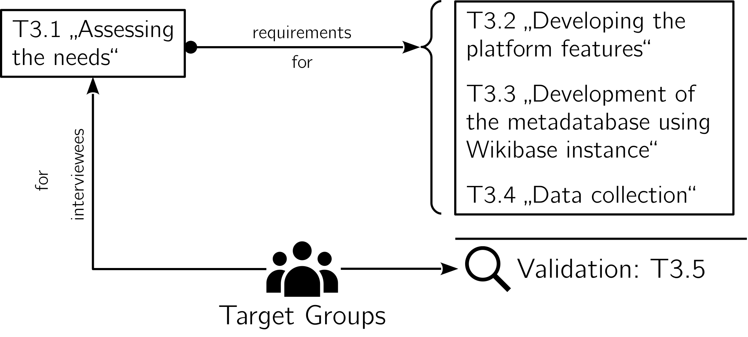Figure 1: Integration of target groups for the development of IT tools in OPEN_NEXT

Testing plan
In order to validate the features summarised in chapter 1.1 the methods listed in Table 1 have been chosen. Since the tools differ in use case, target group and development status, dedicated testing plans have been designed for each tool. For further details regarding the tools and their development, please refer to the corresponding deliverable reports:
- D2.3 “First release of OSD status report dashboard” (Penyuan et al., 2021)
- D3.2 “Platform demonstrator“ (Sonika Gogineni et al., 2022);
- D3.3 “Wikibase instance demonstrator“ (Häuer & Sonika Gogineni, 2021);
- D3.4 “Populated database“ (OPEN-NEXT/D3.4-Report, 2022).
Table 1: Overview of validation methods per tool
Tool | Method | Related deliverable
Wikifactory frontend | tested by target group | D3.2
Wikifactory Request-for-quotation system | tested by target group | D3.2
Wikifactory import/export tool | validated by application | D3.2
Dashboard | tested by target group | D2.2
Skill-based matchmaking |  | D3.2
ML-based identification of production metadata | performance testing | D3.2
LOSH search | tested by target group | D3.3/D3.4
LOSH backend | validated by application | D3.3/D3.4
LOSH manifest file creator | tested by target group | D3.4
OSH repository checker | validated by application and tested by target group | D3.3
LOSH reporter | validated by application | D3.4

The following chapter outlines how these methods have been applied for the validation of the tools, the results and consequent outlooks.

Validation results

Wikifactory

Wikifactory frontend

Short description

Validation method

Validation results

Summary & outlook

Wikifactory import/export tool

Short description
allows for transfer or files from one platform to another, when developing open source hardware online (currently Google Drive, Dropbox, Wikifactory and git-based services (such as GitHub or GitLab). Hence providing communities and companies with the ability to move projects across platforms without facing vendor lock-in. The tool is currently available as a standalone software package and will be integrated into the Wikifactory platform.

Tool and source code are available here.

Validation method
implemented into the backend → validated by use

Validation results

Summary & outlook

Collaborative production tools

Request-for-quotation system

Short description
The now available “request for quotation” system on the Wikifactory platform (https://wikifactory.com/marketplace/) helps matchmaking hardware designs with suitable manufactures (currently 260+ manufacturers for 3D printing, CNC, sheet metal fabrication and injection moulding).

Validation method
user tested (OPEN_NEXT SMEs and representatives from the OSH community) + heuristic analysis

Validation results

Summary & outlook

ML-based detection of production metadata

Short description
In the OSH community, there are several methods for collecting and documenting information about projects. The style and structure are different and result in unstructured documentation. It is impossible for collaborators to get an overview of the project and obtain necessary information without reading the entire documentation. To tackle this challenge, an application is created that uses Named Entity Recognition (NER) to identify selected metadata properties of LOSH, namely manufacturing process, machine type, material, and dimensions. The NER algorithm is created by running the NER detection model from spacy (spacy.io). The model is evaluated with some test websites from Appropedia (appropedia.org) and the accuracy values are obtained.

Validation method
Validation was performed for the two aspects of the solution:
- Word Cloud: Appropedia websites were identified for the word cloud. Appropedia websites have a section for keywords that was manually filled in. The automatically generated word clouds are compared to see if they match.
- NER algorithm: NER is evaluated based on the precision, recall and f-score of the training model. The hyperparameters of the model are set to obtain the best accuracy values.

Validation results
The results of Wordcloud for the project called Recyclebot from Appropedia are shown in Figure 3. Figure 2: Appropedia keywords also shows some manually created keywords. After comparing the two, the results show an overlap of 40% to 80%. Some manually entered keywords did not appear in the word cloud because they were not included in the written text.
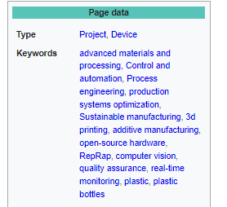Figure 2: Appropedia keywords
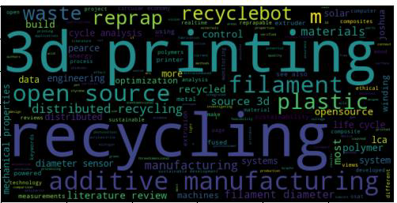Figure 3: Results of wordcloud
The results of NER algorithm are shown in Table 2. Changing some hyperparameters like drop out value the model with the best precision, recall and f-score is selected. Optimum accuracy was received when dropout was set as 0.5.
Table 2: Results of NER with different dropout
Dropout value | P | R | F
Dropout 0.1 | 75.05 | 57.61 | 65.43
Dropout 0.2 | 71.05 | 58.70 | 64.29
Dropout 0.3 | 80.88 | 59.78 | 68.75
Dropout 0.4 | 86.54 | 48.91 | 62.50
Dropout 0.5 | 76.25 | 66.30 | 70.93

Another hyperparameter called learning rate was also varied and set an optimum as 0.001 as shown in Table 3. This optimum values are saved and used.

Table 3: Results of NER with different learning rate
Learning rate | P | R | F
Learning rate 0.001 | 79.22 | 66.30 | 72.19
Learning rate 0.005 | 80.30 | 57.61 | 67.09
Learning rate 0.01 | 81.82 | 58.70 | 69.82

Summary & outlook
The research presents the development of a methodology and application for extracting metadata from unstructured online data of OSH projects. The solution primarily targets online platforms such as the project partner Wikifactory or the community partner Appropedia in order to automatically create keywords or highlight them in the text for better overview. It is also possible to use the algorithm to match the categories found under manufacturing process, material, machine type and dimensions. Makerspaces or fablabs can be offered according to their particular manufacturing processes and machines so that the OSH community can find suitable partners.

Process facilitation dashboard

Short description
Note: The primary work on the process facilitation dashboard takes place in OPEN_NEXT T2.2 with two deliverables D2.3 and D2.5. Please refer to those deliverables for details on the development, implementation, and delivery of the dashboard. Here, we will briefly describe the overall concept of T2.2, and the step in D2.5’s development that was opportunistically validated along with other tools in deliverable D3.5.
The T2.2 process facilitation dashboard concept is a visualisation of various “health” indicators showing the evolution of an OSH project; its design activities; or progress towards success based on project goals. To this end, T2.2 conducted the following phases of development:
- Proof-of-concept in D2.3 (Penyuan et al., 2021) where we delivered a technical demonstrator that mines the metadata from various OSH repositories hosted on Wikifactory and GitHub. It calculates metrics related to the health of the projects and shows simple visualisations. This demonstrator puts into action the conceptual workflow of deriving and showing project status metrics. The fully open source code behind this initial proof-of-concept was published as part of D2.3.
- Re-architect the technical infrastructure of the dashboard with a clear separation between backend and frontend (Figure 4 below). The backend is a “behind the scenes” application programming interface (API) hosted on a web server. It programmatically receives requests for project health metrics regarding a specific OSH repository hosted on Wikifactory or GitHub. The backend will then query the Wikifactory or GitHub APIs to obtain raw metadata about said repository, calculate the metrics, and send the results. The frontend would be a user-facing web interface that makes API calls to the backend and visualises the information from the backend. T2.2 has developed an updated backend for this purpose to be delivered in D2.5. It will also include a demo frontend as a technical demonstrator of the capabilities, plus a “real life” implementation of the frontend by Wikifactory and put into production on their platform.
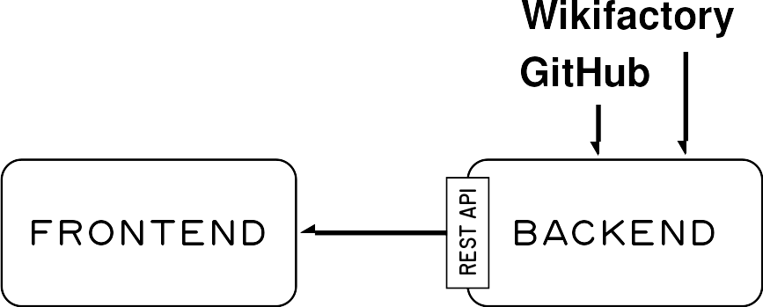Figure 4: Updated technical architecture for T2.2 process facilitation dashboard
- With the goal of delivering dashboard elements integrated into Wikifactory, we conducted a requirements capture study. This was done with OSH experts within OPEN_NEXT and Wikifactory as a practice partner. During this process, we enumerated (a) nine key stakeholder types related to Wikifactory; (b) six categories of information needs by those stakeholders; and (c) 50 possible dashboard features which fulfil the information needs (and, by extension, the stakeholders). Of the 50 features, we prioritised a list of the top 10 through a focus group including Wikifactory. Of the 10, two were implemented as a starting point for the next phase.
- Conduct evaluations in the form of online surveys and validation events coordinated between T2.2 and T3.1. For the T2.2 dashboard, these actions serve to obtain feedback from OSH practitioners on the 10 features from the requirements capture study. The feedback can then be used to order the 10 features for them to be developed and implemented in a stepwise faction by Wikifactory.
- As Wikifactory continues to implement the 10 dashboard features and put more of them into production, T2.2 has produced a new demo frontend that shows a comparable set of dashboard features but derived from OSH repositories hosted on GitHub. This demonstrates the applicability of the dashboard beyond GitHub, and provides an actionable blueprint for other platforms. In addition, individual OSH projects can selectively self-host the stack, frontend and/or backend, to implement the dashboard on their own. Please refer to D2.5 for details.
As mentioned above in 4., T2.2 conducted various evaluations of the dashboard features. As part of that effort, T2.2 joined a validation day hosted by T3.1 involving OSH practitioners. The rest of this section will describe the specific validation effort taken by T2.2 to make use of the validation day organised by T3.1 to obtain feedback.

Validation method
The surveys conducted as part of T2.2 with distribution support by T3.1 are described in D2.5. In addition to that, T3.1 organised a validation day involving OPEN_NEXT SMEs and representatives from the wider OSH community. Because one component of T2.2 is developing user-facing dashboards integrated into Wikifactory, and that WP3 also develops a suite of technical tools related to OSH, we set up the validation day to obtain feedback on T2.2’s 10 dashboard features.
This validation day occurred on 27 May 2022 where T3.1 invited OSH practitioners both within and outside of the OPEN_NEXT project. For details please see section 2.2.1.2. The validation day was an interactive virtual session to provide feedback on design concepts of T2.2 dashboard features and ICT tools developed by WP3.
During the validation day, about one hour was dedicated to feedback about the dashboard. Participants were shown screenshots or mock-ups and given to chance to provide verbal feedback, plus complete an online survey to give written feedback and scores and rankings to each feature.

Validation results
Note: Detailed results are in D2.5.
Also, the validation day confirmed that the two initial features planned by T2.2 to be deployed into production on Wikifactory are generally useful for OSH practitioners. These features are:
- Detailed license information about a project – In addition to detecting and displaying the name of the open source license (e.g. CERN-OHL-S), high level explanations of each term in the license is displayed in an interactive manner.
- Breakdown of file types – A visualisation of primary file types in the repository organised by category: electrical CAD, mechanical CAD, images, data, documents, and others. This would give visitors to the project a sense of where its primary work is focused on (e.g. an electrical engineering-focused project).

Summary & outlook
After the validation, the two initial validated dashboard features described above were implemented on the frontend of Wikifactory, and are now live in production. This frontend is tied into a deployment of the backend server developed within T2.2, which demonstrates the practicality of D2.5 in a real-world scenario. The surveys we received feedback for during the validation day also informed a revised version that was more widely distributed to OSH communities. This feedback will allow us to prioritise the other features to be developed in T2.2 and Wikifactory.
While the absolute number of people who completed the survey and attended the validation day was limited, we believe our pioneering efforts are a healthy start given the relative young age of the OSH community especially in contrast to more mature open source software communities.
In any case, we have realised, through T2.2 and D2.5, real business value by putting the developed dashboard components into production on Wikifactory to benefit its users. This benefit will continue to materialise, even after the OPEN_NEXT project, as more of the prioritised and user-tested features are implemented by Wikifactory.

Skill-based matchmaking

Short description
The Skill-based matchmaking module aims to connect project needs with contributor capacities within open source communities. An open source project can tag open issues with specific skills needed to fulfil those tasks, while contributors can “earn” skill tags when working on these issues (e.g. solving an issue tagged with “python” presupposes that the contributor is skilled in programming, specifically the python language). The service is currently embedded into the Wikifactory platform so that new issues in issues can bear skill tags, illustrated for a sample issue in Figure 5.
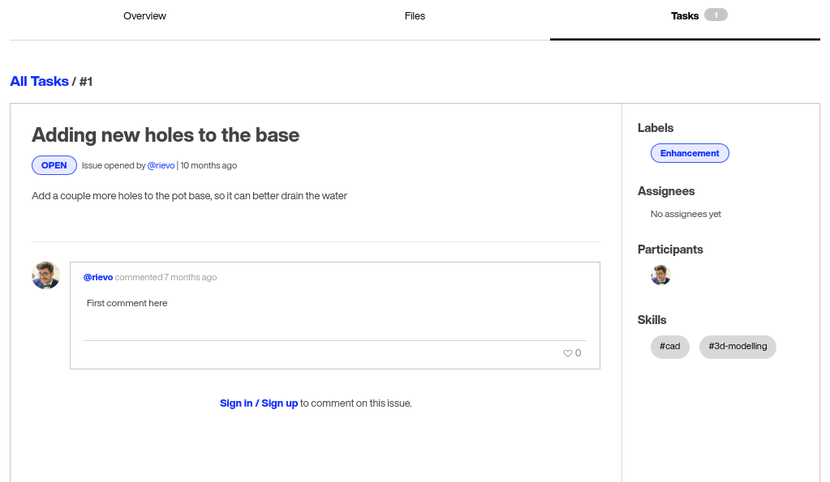Figure 5: Detail screenshot of a sample issue with skill tags on the Wikifactory online platform
The source code of the tool has been published under a free/open licence on GitHub:
https://github.com/OPEN-NEXT/WP3_Skillmatching .

Validation method
The validation process of the skill ontology demonstrator is divided into two parts. On the one hand, it included the confirmation of the functionality of the demonstrator with regard to the developed requirements on the basis of the user flows. The user flows themselves were developed from the user's point of view and thus contain the functionality for a user against the background of a user interface. This functionality within the user stories was initially developed in the form of competency questions for the ontology in the demonstrator. Competency questions are questions that request an explicit function or behaviour of the user. In this way, core functions can be ensured and the original purpose of the ontology can be validated.
On the other hand, the validation of the skill ontology demonstrator is also focussed on the implementability in a platform. For this purpose, the first stage of the ontology demonstrator was handed over to the implementation partner Wikifactory, who implemented the demonstrator on a local version of the platform and gave feedback on the provision and functionality of the ontology. Based on these competency questions, it is possible to explicitly define and address queries to the ontology that confirm or negate its function with regard to the requirements.

Validation results
In the first step, the demonstrator was modified to be able to deploy it in a docker container environment.
The second iteration involves the “localisation” of the ontology. In the first stage of the demonstrator, the ontology was hosted and accessed in the public project repository. For this, user data was anonymised in order to make it publicly available. For use within the platform, however, the original user data is required in order to link the ontology data to actual users. For this purpose, services had to be developed to host the ontology with its data locally and privately within the demonstrator.
Another point was the timeliness of the user data. In the first stage, these data were static, i.e. query results from user data, provided via the Wikifactory Graphql API, were stored as JSON files in the demonstrator. Updating was not implemented as a function, which is an exclusion criterion for practical use of the demonstrator on the platform. This function was added later. The “localisation” also changed the query function with regard to endpoint and address mechanism and was adapted accordingly.

Summary & outlook
The scope of the validation of the skill ontology demonstrator was to test its successful functionality with regard to the requirements developed for it at the beginning in the form of the presented user flows and to test its general implementability on an exemplary platform. This could be essentially confirmed by means of the validation described in the preceding chapters. Looking ahead, the demonstrator is to be further examined for usability and integrability. There are many aspects of the individualisation of individual functions that need to be considered further, which expand the initial horizon of consideration. This includes, for example, consideration of:
- different locations of the data sources,
- different data formats for the instances,
- simultaneous instantiation of multiple data sources,
- different data formats for instantiation into the ontology,
- other mapping approaches,
- Scalability studies,
- real-time instantiation based on posed queries.
This outlines just a few examples. For reasonable extensions, more extensive user studies are first necessary in order to define, meaningfully delimit and evaluate a further development horizon.

LOSH

LOSH search

Short description
The “Library of Open Source Hardware” (LOSH) features a distributed knowledge base for OSH designs. The knowledge base is fed automatically by a crawler and from different online platforms, automatic quality checks are performed on that data before uploading it.
LOSH search has been deployed as a free-of-charge online service to support users to find existing OSH solutions for design reuse or replication. This features the primary use case of the LOSH knowledge base; primary target groups are SMEs, OSH community members and researchers.
For instance, SMEs can use LOSH during ideation to explore what has been done, how and by whom. This helps to:
- find a feasible design for a specific problem, while considering practical limits visible in existent, similar solutions;
- reduce development efforts by (possibly) directly copying (parts of) existent solutions for the desired use case;
- get connected with the communities behind relevant solutions in order to collaborate on joint efforts.
The LOSH search service uses a minimalist, clear design to support the intuitive use of the service without distraction. Figure 6 shows a corresponding detail of the landing page, which can be accessed under https://losh.opennext.eu/ .
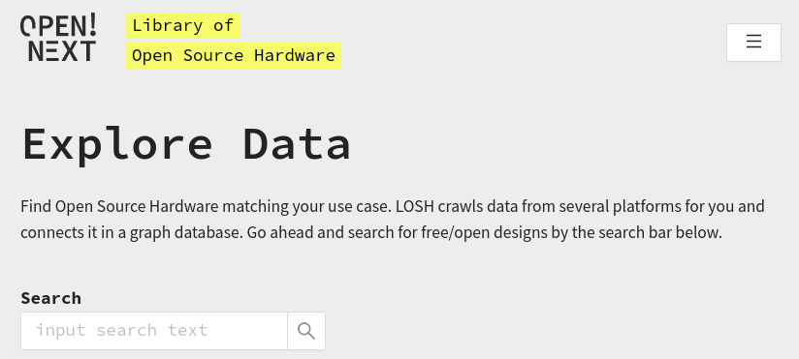Figure 6: Detail of the search bar of the LOSH landing page
The backend of LOSH scans supported OSH online platforms for OSH repositories relevant for design reuse and keeps metadata about them. When searching for OSH designs, users are rerouted to the original repositories – this is illustrated in Figure 7 below. That way 1) OSH developers keep full data sovereignty and 2) users always view the primary source of information at its latest status. For details please refer to section 2.2.3.
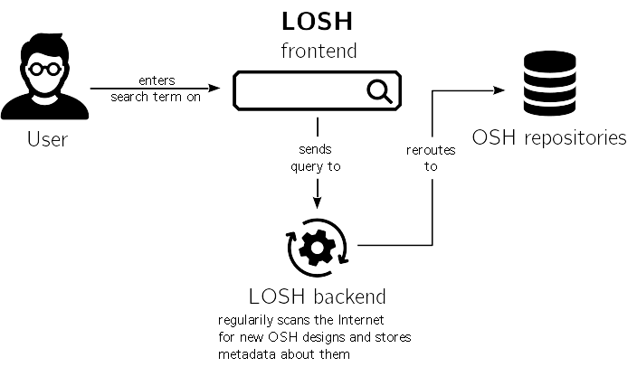Figure 7: Schematic illustration of how the LOSH search service works
The source code of the tool has been published under a free/open licence on GitHub:
https://github.com/wmde/LOSH-Frontend/ .

Validation method
The search functionality of LOSH has been identified a key feature in previous tasks of the work package (for further details please refer to the reports for D3.1 „User stories of collaborative engineering needs“ (Gogineni, 2020) and D3.3 „Wikibase instance demonstrator“ (Häuer & Sonika Gogineni, 2021)). The function has been tested in its production environment (hosted under http://losh.opennext.eu/) by:
- representatives of the target groups to assess the practical value of the tool,
- internally using the heuristic analysis method resulting in more detailed outputs and suggestions to facilitate further developments and bug fixing.
Representatives of the target groups (“user testing”) had no or only minor experience with LOSH and related tools and material, such as the OKH-LOSH specification and where thereby treated as independent users that had no contact with LOSH before the testing.

User testing
The user testing with the target groups has been carried out in two sessions:
- in an internal workshop with SMEs piloting open-source-based business models in OPEN_NEXT to give space for committed representatives of the primary target group of this project to provide high-quality feedback; for data input a survey was used, further feedback was directly documented in the form of issues in the respective GitHub repository;
- with a larger group of actors in the field of OSH (SMEs, makerspaces, researchers and community representatives) using only a survey with instructions and small tasks to complete while using the LOSH search functionality. Invitation eMails to the survey were send after the self-explanatory nature of the survey, hence allowing for independent input, was validated during the workshop.
The latter on the one hand brought unbiased feedback from representatives of a target group that have never been in contact with LOSH before and on the other helped to communicate the release of LOSH. The surveys used for data input were identical in both sessions.
Table 4 gives a quantitative overview of the notified groups that have been contacted for this validation. The exported raw data of the survey results as well as the survey itself and the invitation eMails can be found in the folder “LOSH-survey” in the folder “raw data“, attached to this report.
Table 4: Quantitative overview of notified groups for the validation of LOSH
Name | Category | Recipients | Returns
OPEN_NEXT Consortium + Demonstrators | OSH SME | 35 | 1
OPEN_NEXT Consortium + Demonstrators | OSH research | 38 | 1
OPEN_NEXT Consortium + Demonstrators | fablab/makerspace | 21 | 0
OPEN_NEXT Consortium + Demonstrators | other consortium partner | 24 | 0
Open Source Ecology Germany | OSH community (OSH projects yet without relevant commercial use) | 406 | 1
D3.1 interviewees | OSH SME | 11 | 0
D3.1 interviewees | fablab/makerspace | 2 | 0
D3.1 interviewees | OSH community (OSH projects yet without relevant commercial use) | 6 | 0

As the return rate was very low, user testing data does not qualify for a quantitative study. However, as shown below in section 2.2.1.3 the qualitative data resonates with the findings from the heuristic analysis. The results of both analyses indicate issues that would need to be resolved before more data could provide more insights at a reasonable level. Consequently, further user testing can be seen as redundant at the current state of development.

Heuristic analysis
A first heuristic analysis has been carried out in the former deliverable D3.4 „Populated database“, evaluating the usability of the frontend. For further details please refer to the respective result report attached to the D3.4 report (OPEN-NEXT/D3.4-Report, 2022). However, dedicated evaluation of the search functionality was not carried out for D3.4.
To test the search functionality of LOSH, the instructions and tasks from the survey for the user testing (see the previous section) have been followed internally by developers of LOSH, while errors and potential flaws have been documented as issues in the GitHub repository of the LOSH frontend. For this, the perspective of an SME has been taken, seeking to reuse OSH documentation for commercial use; at best by replicating the OSH design (or parts of it) directly or using it as source of inspiration to develop a respective product.
To use representative search terms, the 10 most frequent search terms from the general purpose OSH search engine „Open Hardware Observatory“ (OHO) have been used. For an overview of these and search terms from the user testing, please refer to section xxx in the annexure.

Validation results

Overview
In the survey, participants were asked to:
- search for OSH designs of any kind, optionally using filters,
- analyse the search results and check the original repositories of most relevant results,
- document their impressions and import all relevant data to the survey form.
The results did not show any significant correlation to whether the participant was part of the OPEN_NEXT project or not. Also the heuristic analysis came to very similar results, consequently results have been analysed jointly as one dataset.
Where participants asked to rate a specific attribute (e.g. usefulness of available search functions), integers between 1 and 5 were allowed.

Relevance of search results and maturity of search functionality
In the survey, participants were asked to:
- search for any technology (entered search terms were for instance “washing machine” or “microscope”),
- rate their first impression of the search results,
- identify one results that they find most relevant,
- analyse it in more details and rate its relevance for them.
This features the default scenario of the intended use of the LOSH search interface (as illustrated in Figure 7 above), covering all relevant functions. During the workshop, participants could follow the survey and fulfil the tasks without any questions. Free feedback regarding the usability of features did not mention any uncertainties, issues or confusion when using the LOSH interface; this was the case for both, input during the workshop and independent input. Neither was confusion about survey tasks or questions mentioned. It was concluded that:
- the survey was clear for participants and
- the LOSH search interface allowed for an intuitive, independent use.

Figure 8 shows the distribution of ratings of the relevance of the eventual selected most relevant search result (n=19). In roughly 1 of 2 cases participants were able to identify at least one OSH design that they rated with a relevance of 4 or higher, only in about 1 out of 7 cases they couldn’t identify an OSH design with a relevance beyond 2.
Figure 8: Distribution of relevance scores of the most relevant result found in one search
The first impression however of the relevance of search results was rated with an average of 3,05 and a high variance of 1,83. For comparison, the average relevance score for the selected most relevant result per search was 3,58 with a variance of 1,81. A correlation between these two scores could not be shown. Roughly, when 7 independent searches are performed, in 3 cases the most relevant result is beyond the first impression, in 3 cases equal and in 1 below.
The usefulness of available search functions was rated with an average of 3,21 with a low variance (0,18). Values tended to be a little higher, when participants found the search results more relevant, but not lower when results were found to be mostly irrelevant.
The tests have shown that users are eventually able to identify relevant results, but were struggling to separate them from irrelevant results. Especially the free feedback from the workshop, the independent user testing and the findings from the heuristic analysis provided valuable input on how the search functionality can be improved. The findings were clustered and documented as issues (13 in total) in the respective GitHub repository and rated regarding their severity/potential value of improvement. While the practical effort to resolve these issues could not be assessed, it became visible that a small set of features and bug fixes could already improve the search functionality significantly. For details please refer to chapter xxx in the annexure of this report.
Despite of that, it is to mention that the search service was very stable during testing. Neither dead links/references, nor empty repositories or non-OSH was identified during the evaluation.

Quality of metadata
From a technical perspective, the quality of metadata in the LOSH knowledge base mainly depends on a) its source, as different repository hosts provide different metadata through their API and b) the informative value of data as provided by the developers of an OSH design. The richest and most complete metadata is potentially delivered by “manifest files” which are plain text metadata files usually created by the originators of the OSH design and in full compliance with the OKH-LOSH specification. Whereas the repository host Thingiverse (https://www.thingiverse.com/) only provides a fraction of these metadata due to heavy limitations of their API. However, some mechanisms have been deployed in the backend of the LOSH knowledge base to cope with these shortages. For instance, in the case of Thingiverse the open documentation and open technology readiness levels are assessed from the available data. Find more details about these scales in (Mies et al., 2022). This matter has been discussed in the prior reports D3.3 (Häuer & Sonika Gogineni, 2021) and (OPEN-NEXT/D3.4-Report, 2022), please refer to them for further details.
The quality of metadata was evaluated for OSH designs that have been identified as the most relevant results. First the informative value of available metadata of a selected most relevant result was assessed. Afterwards the repository of the result was checked and it was evaluated whether or not the metadata represents what was found in the repository. Figure 9 shows the scores for the informative value of metadata for the results, Figure 10 the evaluation whether or not the metadata was found representative. For comparison, Figure 11 shows the rating of relevance of the selected OSH design.
Figure 9: Rating of informative value of metadata of most relevant results
Figure 10: Responses to the question, if the metadata represents what was found in the repository of the most relevant result
Figure 11: Rating of relevance of most relevant results
The average ratings of the informative value of metadata and the relevance of the selected results was compared: among repository hosts, as shown in Table 5, and for the different cases of how representative the metadata was found, as shown in Table 6.
Table 5: Average ratings of the informative value of metadata and the relevance of the selected results for different repository hosts
Repository host | Average informative value | Average relevance
OHO | 3,75 | 5
Thingiverse | 2,9 | 3
Wikifactory | 2,75 | 3,75

Table 6: Average ratings of the informative value of metadata and the relevance of the selected results for different cases of representativeness
Metadata representative? | Average informative value | Average relevance
Yes! | 3,45 | 4
Sort of… | 2,4 | 3
Not really | 3 | 3
Cannot tell | 2,5 | 3

In the data, no correlation between the rating of the informative value of metadata and the relevance of the selected most relevant result could be shown.
As expected and shown in the figures above, the informative value of metadata differs among repository hosts. Even though ratings were sometimes low, testers have found the available metadata to reflect the content of the repository in about 4 of 5 cases. Ratings of the informative value tended to be a little higher, when the metadata represented the OSH design repository well, even though no correlation between these values could be shown. Also considering the input from comments, it was concluded that users know what to expect from the repository when viewing the metadata, but additional meta information would significantly support the search process. Ratings of the informative value of the metadata were higher when good functional descriptions were given, more insightful metadata was available (e.g. patent class, technology readiness level, documentation readiness level) and also when images were available. The availability of insightful metadata and images is a technical dependence on the APIs of the repository hosts. In the user testing, participants suggested additional metadata fields that would support their search. All of these have been suggested for earlier versions of the LOSH frontend during interim user testings, but could not be realised due to technical limitations.

Summary & outlook
Despite of the very ambitious vision of LOSH, becoming the largest knowledge base for OSH designs in only 2 years of development, the result has shown the accomplishment of this mission – and unveiled many options for further improvement. The whole system has been exceptionally stable throughout the validation phase.
Data and insightful comments from the testing led to the following conclusions:
- The LOSH knowledge base includes enough high-quality OSH designs to be relevant for technology research – independent from the technology category. Within the sample, this was the case independent from the type of technology that was searched, which might qualify LOSH for a general-purpose meta search engine for OSH designs.
- Search results are better than expected at first. The average relevance of ultimately selected most relevant search results was significantly higher than user expected from the first impression of initially displayed search results.
- The LOSH search service fulfils the use case, but would greatly benefit from an improvements of the search functionality. Available search functions demonstrated that they enable users to find relevant OSH designs, but users often to separate relevant from irrelevant results. However, a small set of features and bug fixes could already mitigate this issue significantly.
- Available metadata reflects OSH repositories, but should be richer. The available metadata gave users a good indication of what to expect from a repository before checking it in detail. However, more insightful metadata and images would significantly support their search.

–
The LOSH search service delivers the required functionality of a general purpose meta search engine for OSH designs – featuring the first of its kind. The service is used by OPEN_NEXT SMEs – and appreciated, see the original testimonial of OSKAR’s maintainer below in Figure 12.
Translation: “Text based interface, reduced to the important functions, that is well accessible. HTML elements describe the function (button, header, etc.). Much easier to use for blind and visually impaired people than Thingiverse. Through this access we want to extract more information from [data] silos. Please continue the good work.”
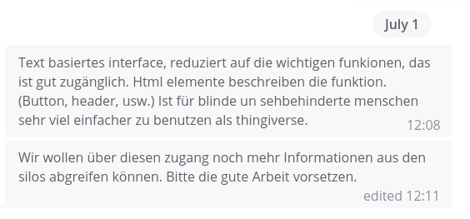Figure 12: Testimonial of OSKAR's maintainer for the LOSH search functionality
The flaws and suggestions for improvement found during testing have been translated into technical requirements and documented as issues in the respective GitHub repository, supporting developments and fixes for the next versions. The WP3 team has been collaborating with OSH communities since the very beginning of the OPEN_NEXT project and started a coordinated handover of project results. The Internet of Production Alliance and the OSEG community committed to take over the joint hosting, maintenance and further development of the LOSH ecosystem. While the work of WP3 of the OPEN_NEXT project has ended with this deliverable, the OSH community will pursuit the vision of an explorable, modular network of OSH designs.

LOSH manifest file creator

Short description
The OKH-LOSH Manifest File Creator offers a web interface to create, manipulate or fix manifest files. A Manifest file is a plain text file containing metadata about an OSH project. For platforms that don’t offer a suitable API for the LOSH backend to extract informative metadata (such as GitHub), manifest files are the only way to integrate OSH projects into the LOSH knowledge base. The same applies to online hosting services that don’t provide any API at all (such as project-specific web pages or the Appropedia platform) – as long as the access to manifest files can be communicated to the LOSH backend, metadata can be extracted.
However, writing plain text metadata files can be challenging for users with no prior coding experience. Syntax errors would result in failed data parsing, while the user itself wouldn’t get any feedback on whether their manifest file is corrupt as the error occurs during crawling.
The tool is configured by the official JSON schema deployed alongside with the OKH-LOSH specification. When the specification is changed (by changing the JSON schema), the data fields in the interface of the OKH-LOSH Manifest File Creator change accordingly. Since the tool is meant to be further maintained on a community basis, it has been designed in a way to keep these maintenance efforts at a minimum.
The source code of the tool has been published under a free/open licence on the GitLab instance of OSEG, which also hosts all LOLOSH-relatedools:
https://gitlab.opensourceecology.de/verein/projekte/okh-losh-manifest-creator .
Deployment of the tool is done using GitLab’s “continuous deployment” functionality. Hence, no further installation steps are required to use the tool.
With the OKH-LOSH Manifest File Creator users can create, edit and validate manifest files without needing to read and understand the OKH-LOSH specification or the required syntax for the defined data fields. The tool can be accessed under the following URL and runs in the browser: https://manifest.opennext.eu/ .
The interface is kept minimalist and is split into two sides, as shown in Figure 13.
Manifest files can be either created directly in the web interface (using the left side of the page) or uploaded and edited. The final manifest file is shown on the right side of the page. Editing is allowed on both sides as they are synchronised. Consequently, users could edit or paste sections directly on the “code side” (right) and presume in the dialogue boxes on the left.
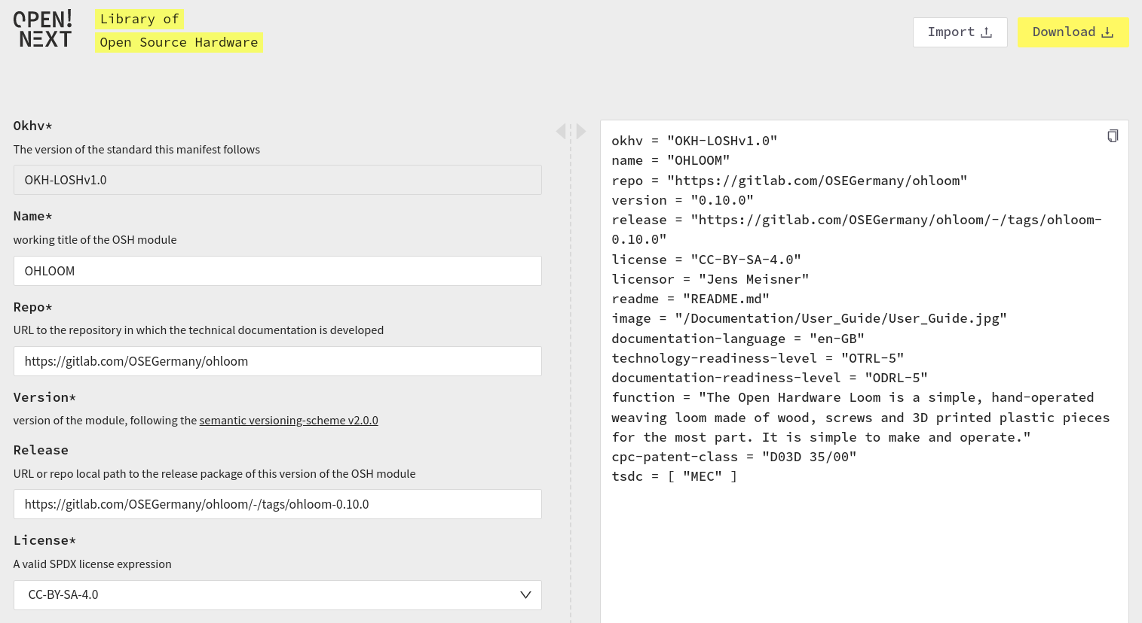Figure 13: View of the interface of the OKH-LOSH Manifest File Creator while editing an uploaded manifest file
Where possible, the interface offers tooltips and predefined options to choose from, e.g. a drop-down menu containing all officially endorsed free/open licences. This should additionally support users when determining metadata for their OSH project for the first time. Not yet filled, mandatory fields are highlighted, as shown in Figure 14. Consequently, the tool includes an automatic validation of manifest files to ensure that resulting files can be parsed by the LOSH backend without errors.
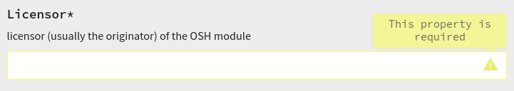Figure 14: Detail view of a highlighted mandatory field

Validation
The tools was developed in a late stage of the project after user feedback in an interim test session indicated its value. During development its scope has been reduced to the core idea to deploy a stable service by the end of the project. The validation was performed together with the LOSH search module in a workshop and independently using a survey. The raw data is included in the folder “LOSH-survey” in the folder “raw data” attached to this report.
The results mainly consist of free form feedback unveiling bugs, questions and suggestions for improvements. Insights have been clustered, translated into technical requirements and documented as issues in the respective GitLab repository as summarised in section xxx of the annexure. The majority of issues and suggested improvements go beyond the original scope of the tool, which shows that users see more potential use cases in the service than originally defined for the development by interim user tests. Otherwise, all users were able to create valid manifest files, some of them with extensive meta information, without additional information or questions. Consequently, the tool was successfully usable for all users within the (narrow) priorly defined scope.

Summary & outlook
The user testing has shown that the service fulfils its intended purpose of providing developers with an intuitive interface to create valid manifest files instead of coding them by hand. The same service allows for validation and modification of existent manifest files. However, for an effective use of the service, prior knowledge about the OKH-LOSH specification is needed. As testers suggested in their feedback, best practice examples of OSH projects alongside with their manifest file may already fulfil this need. The evaluation has shown that the scope of the tool has been set too narrow during its development as users seem to see much more potentially useful features. Being the slowest (but richest) method for data input within the LOSH ecosystem, the creation of manifest files can be significantly supported using this web-based service, but would greatly benefit from further development.
Future works as well as continuous hosting and maintenance of the service will be carried out by the Internet of Production Alliance and the OSEG community.

LOSH backend

Short description
The “LOSH backend” includes all modules of the LOSH ecosystem that are necessary to run the system, but are not designed for any user interaction. The related modules are designed to:
- operate fully automatically,
- be easy modifiable by developers or admins in case of necessity,
- be easy deployable and remixable by other stakeholders for their projects.
Table 7 shows the OSH online platforms the LOSH backend supports at the moment. The system supports four methods of data upload:
- directly from the API of the OSH online platform (fully integrated platform),
- using manifest files found using the API of the OSH online platform (connected platform),
- using additional custom scripts and manifest files (associated platform),
- direct upload via the Wikibase API.

Table 7: Overview and reference to current data sources covered by the LOSH backend
Data source | Upload method | URL
GitHub | Manifest files | https://github.com/
OSHWA Certification List | API | https://certification.oshwa.org/list.html
Wikifactory | API | https://wikifactory.com/
Thingiverse | API | https://www.thingiverse.com/
Appropedia | Manifest files, collected by a scraper, uploaded to GitHub | https://appropedia.org/
OKH-Search | Manifest files, collected by a scraper, uploaded to GitHub | https://search.openknowhow.org/
manually curated data set | Manifest files in a dedicated repository on GitHub | https://github.com/OPEN-NEXT/LOSH-list/tree/main/manifest_files/manually-created
OSEG-CAB | Manifest files in a dedicated repository on GitHub | https://github.com/OPEN-NEXT/LOSH-list/tree/main/manifest_files/manually-created/OSEG-CAB
OHO-CAB | Manifest files in a dedicated repository on GitHub | https://github.com/OPEN-NEXT/LOSH-list/tree/main/manifest_files/manually- created/OHO-CAB

Figure 15 below illustrates the data flow inside the LOSH backend. The backend as a whole applies an ETL cycle (Extract, Transform and Load data):
- copy data from defined, heterogeneous sources (OSH online platforms) after defined criteria using the Fetcher module,
- convert collected data into linked open data (LOD) using the RDF format (Resource Description Framework) using the OKH-LOSH specification and ontology to make it available for further purposes such as querying and analyses using the RDF-Converter and upload the converted data to defined data stores using the Wikibase-Pusher and WikibaseReconcileEdit,
- storing the LOD and making it available for several other software modules (such as the frontend for the LOSH search service (see section 2.2.1)) using Wikibase.

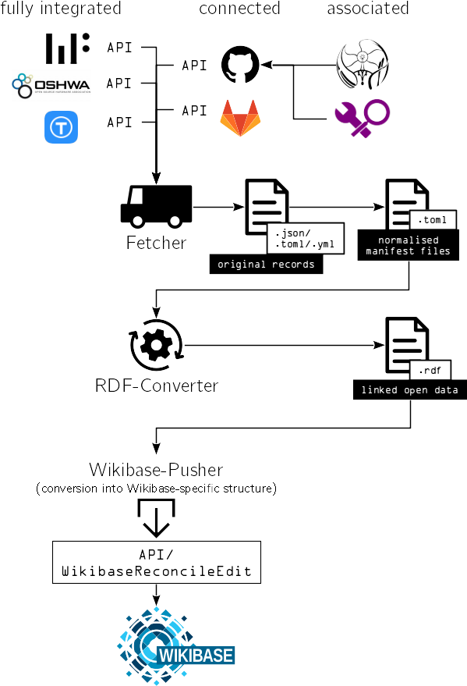Figure 15: Data flow within the LOSH backend with associated modules
Following the Unix philosophy, each of these modules can be executed independently and the output of one module is expected as input for another (even unknown) module. Consequently, the data flow is easily adoptable and remixable totally independent from the LOSH ecosystem. For instance the LOSH reporter module (see section 2.2.4) accesses the raw RDF data generated by the RDF-Converter and hence acts as an “external user”, validating this point.
This practice of software design keeps code complexity low, also lowering the barrier for external contributors to modify the software. As a result the backend is easy to run (or host), test, customise, maintain and develop further. This was key requirement in development since the tool is meant to be further maintained and developed by the OSH community. As a side effect of this practice, software modules become applicable to a large variety of use cases including many not envisioned by the original developers.
All related modules and scripts of the LOSH backend have been published under a free/open license in the GitHub repository of the OPEN_NEXT project. For further details on modules and data flow, please refer to (OPEN-NEXT/D3.4-Report, 2022).

Validation & outlook
Deployment of the latest version of the LOSH backend was finished in May 2022, after running through regular iteration cycles. Since then no major issues occurred, the backend system and all related services building on top of them operate fully stable, validating the functionality of the software modules. The deployment was performed by OSEG who also committed to a continuous hosting of the service free of any charge for at least 3 years after the OPEN_NEXT project has ended. The further development of the tools will be conducted by a collaboration of OSEG and the OKH community. As reported by a developer from OSEG, the next steps will focus on the improvement of the performance of the backend since its current version tends to need lots of computing resources due to the quantity of data. These optimisations will lower hosting costs and by that also enable more independent parties to host (parts of) the system.

LOSH reporter

Short description
The OSHdata project was an initiative from the OSH community to give an overview of the current situation in the OSH community by crawling data from the OSHWA certification list. The initiative published annual reports containing mostly statistical evaluations (a sample is shown in Figure 16 below) and distributed them in several social media channels, reaching e.g. over 580 followers on twitter. The last report was published for 2020; the project was shut down thereafter due to a lack of resources. In 2021, the Open Hardware Observatory e.V. (non-profit) took over the OSHdata project in a collaboration with OPEN_NEXT.
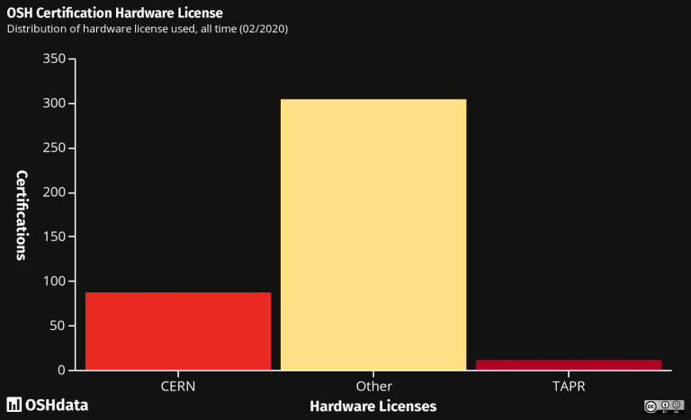Figure 16: Sample from the OSHdata report 2020 showing the distribution of hardware licences among OSHWA-certified products
The LOSH Reporter is a command line tool with a locally running RDF environment, extracting statistical data from the LOSH knowledge base. Once set up, the tool can also be executed automatically, e.g. on a server. Input of the tool is raw RDF data; as output it generates an HTML file that can be easily hosted as a web page (e.g. on OSHdata.com) and a printable PDF. The tool uses a template that can be edited with the FOSS tool jupyter notebook, text blocks are written in Markdown. Although Markdown is technically a programming language, it aims to be easy-to-use for people with no prior coding experience. To generate a new report, only the BASH shell script called “generate” needs to be executed and export files will appear in the “output” folder.
The template, and thus the report, are fully modifiable at low effort. In fact, the tool can be used for any knowledge base or dataset, although it has only been tested with LOSH data yet.
The source code of the tool has been published under a free/open licence on GitHub:
https://github.com/OPEN-NEXT/LOSH-Reporter/ .

Validation & outlook
Like the LOSH backend (see section 2.2.3) the tool was validated by use. As a CLI tool it is geared towards users with relevant IT knowledge, although setup and execution are in principle simple enough to be performed by users without IT background, when strictly following the instructions in the README file. For validation the tool has been deployed locally to generate the very first OSHdata report based on LOSH data – find this document attached to this deliverable report as “losh-report-08-2022.pdf” in the root directory. The report has been handed over to the Open Hardware Observatory e.V. for further distribution.
Although facing a growing demand for third-party proofs of documentation quality, mostly from economic actors and despite large public interest, the OSHdata initiative permanently stopped the publication of statistical reports on this concern – primarily because invested efforts did not compensate themselves sufficiently by a reliable business model:
“Our research paid for itself through consulting projects and made an impact. Hundreds of new products were certified. We spoke with Adafruit and SparkFun. We helped students publish papers. We discussed open hardware in Machine Design. We supported OpenForum Europe‘s work for the European Commission” (OSHdata).
The LOSH Reporter is a tool fully automating (most) of the efforts the OSHdata team was facing before, hence, pushing the costs for the publication of these reports to a minimum. Furthermore the content of these reports is no longer limited to the OSHWA Certification List, but now includes all data sources supported by LOSH (see section 2.2.3.1 for details). Figure 17 below shows a graphic from the LOSH report showing the distribution of repository hosts of OSH designs in the LOSH knowledge base; Figure 18 shows the distribution of hardware licenses among these projects (compare with Figure 16 above from the former OSHdata report)

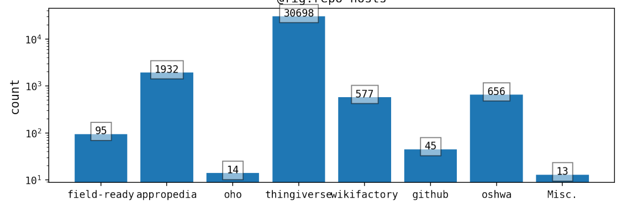Figure 17: Distribution of repository hosts of OSH designs in the LOSH knowledge base
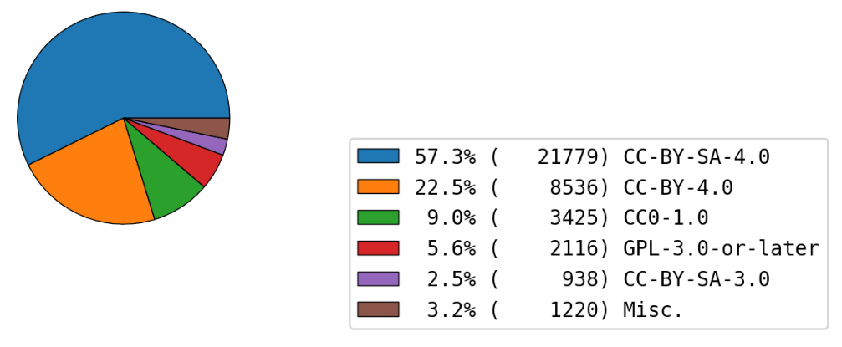Figure 18: Distribution of hardware licenses among projects in the LOSH knowledge base
LOSH reports give a good overview of the current state of OSH. The target group for the reports includes businesses acting or interested in the field of OSH (as the followers of OSHdata’s social media channels) and researchers in the domain of OSH. Apart from that, LOSH reports can also support decision-making processes of policymakers.

The reports are now periodically published in cooperation with the Open Hardware Observatory e.V. (non-profit) under a free/open license.

OSH repository checker

Short description
The OSH Repository checker is a command line tool for quality assessment of OSH projects (“technical project linting”). It checks whether a project repository adheres to community best practices regarding how technical documentation is stored in git repositories (which have been identified to be a top choice for OSH development (Mies et al., 2020)).
The tool analyses locally stored repositories and returns an assessment report. The report uses the markdown format so that it can be pasted directly into the issue description of the corresponding OSH project. The output renders as a To-do list for each yet open point to be resolved for full compliance with community best practices – see Figure 19 and 20.
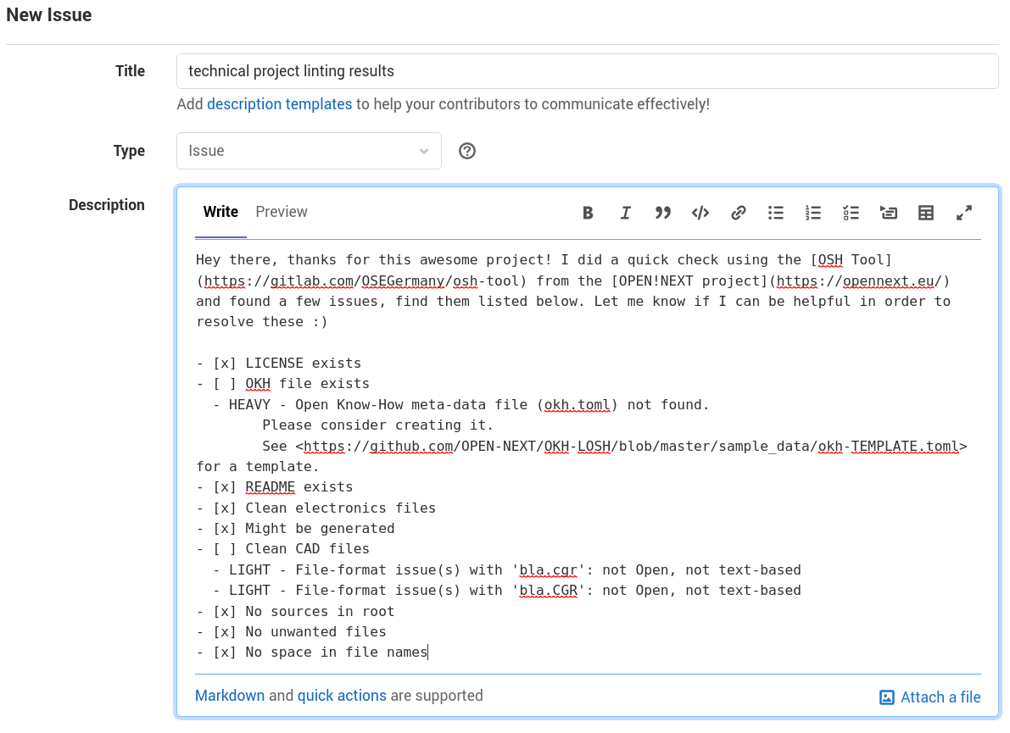Figure 19: Example issue on GitLab with assessment report directly copied from the tool's output
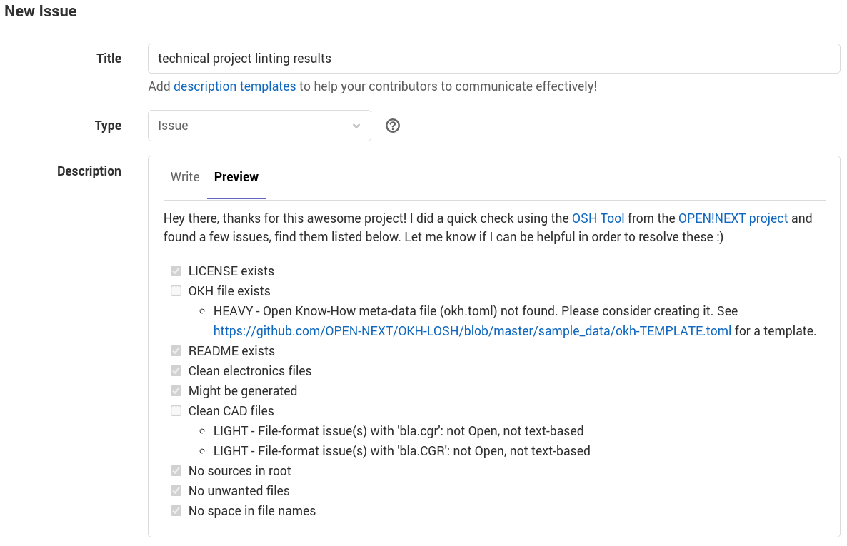Figure 20: Rendered view of the example issue shown in Figure 19
Adhering to such practices has several benefits for different user groups when dealing with the technical documentation of the project, e.g.:
- higher familiarity for users/replicators, external contributors, manufacturers and reviewers (e.g. from conformity assessment bodies according to DIN SPEC 3105-2);
- improved efficiency for git-based services (smaller, easier to handle repositories, meaningful diffs);
- any software dealing with the content can recognise project metadata and essential files (e.g. source files) much easier;
- content can be easier ported to other hosting platforms (or any other system dealing with projects) (less lock-in effect);
- improved comparability among OSH projects;
- improved reusability e.g. when used as a module within another OSH project (e.g. an open source phone using an open source GPS module).
The source code has been documented and published under a free/open licence through the following GitLab repository: https://gitlab.com/OSEGermany/osh-tool .

Validation & outlook
Primarily developed for internal use, supporting the research carried out in WP3, the tool validated its functionality per deployment. However, as it has been developed as FOSS from the beginning, some members of the OSH community started to use it as well – and provided feedback for further improvement in the form of issues in the respective GitLab repository. Feedback covered minor bugs as well as suggestions for further checks and file formats to be supported by the tool. This dynamic indicates that the tool integrates well into the existent ecosystem.
Some of these suggestions have been implemented already during the project. Now the OSEG community took over the further development and maintenance of the tool and started the work on remaining issues. Table 8 gives an overview of the next goals of further development as reported from a OSEG representative.
Table 8: Overview of next development goals for the OSH repository checker
Issue ID | Content | Comment
11 | integrating a validator for the REUSE specification | The REUSE specification defines a machine-readable declaration of licencing terms. This is specifically important for repositories with multiple licences to keep the assignment of licencing terms clear for each file.
12, 13 | add more supported output formats (CSV & JSON) | These output formats allow for a powerful post-processing of the outputs.
18 | develop a validator whether the directory structure is following community best practices | Promoting community best practices for directory structures may help to make repositories of OSH designs more explorable.
14 | develop CI-version of the tool | GitLab offers the deployment of automated scripts (“Continuous Integration” (CI)). Making the tool available as such script would allow for automated quality checks of any OSH repository.

Summary
At the beginning of this work package the collection of concrete needs from for- and non-profit actors in the field of OSH had set the scope for new IT tools to be developed. Since then, the OPEN_NEXT project had teamed up with relevant open source communities to jointly develop a large variety of IT tools to significantly support development of OSH products, specifically to support design reuse and shorten development time.
While it could be validated that all tools provide the envisioned functionality for the defined target groups (and some beyond), their practical value for OSH development could not be validated since this would require a much larger study of their practical use. However, since the scopes for these tools have been set by 20 dedicated 1:1 interviews of representatives from the target groups themselves (Gogineni, 2020), users have (indirectly) defined the features they would like to see in the tools. The results from the validations gave a good indication that user needs are met by the tools.
The further development, maintenance and hosting have been assured for all tools by involving open source communities since the beginning of the development and handing over the results to relevant organisations. All of the developed tools occupy an important niche in the open source ecosystem and seem to integrate well into the existent landscape of open source tools after a fruitful collaboration with relevant communities.
The further development, maintenance and hosting have been assured for all tools by involving open source communities since the beginning of the development and handing over the results to relevant organisations. For some tools (e.g. OSH repository checker or parts of the LOSH backend) the further development has already been started by these communities. Since all of the developed tools occupy an important niche in the open source ecosystem, this dynamic can be seen as an indicator that the tools eventually integrate well into the existent landscape of FOSS tools.
The source codes of all developments as well as all related material (e.g. specifications, instructions or graphics) have been published under free/open licenses, following licensing best practices of the respective communities, allowing anyone to operate, study, modify and distribute the software code or related material as well as derivatives of it.
During research and development actions of this work package, some of the tools (e.g. the LOSH system, the LOSH reporter, the OSH repository checker or the process facilitation dashboard) have also shown their value for research related to open source product development: Relevant data is now available in much larger quantity and diversity in no time and quality of OSH repositories can be assessed much faster. Since the data has shown to cover a large part of the OSH already published online, the statistical reports of the LOSH reporter provide a good overview of the current scene and help researchers, developers and commercial actors where to take a closer look to find relevant OSH designs for their use case – and the associated communities.
The application of the developed tools (e.g. by user testing) have unveiled significant potential for further improvements in order to cover more use cases and extend the economic and technical value of the tools. A continued development of the tools beyond the OPEN_NEXT project as well as further research field by the powerful toolbox of developments of this work package, would further support the development and commercialisation of open source hardware products – and thereby the creation of repairable, upgradable, remixable hardware.

Licenses & attributions
All software and related documents have been licensed under the GNU General Public License Version 3.
This report has been licensed under the Creative Commons Attribution 4.0 International license and made publicly available on GitHub.
The report, including the annexure, uses the following images under free/open licenses:
Image | Name | Author | License
 | document | arjuazka | CC BY 3.0
 | platform | Adrien Coquet | CC BY 3.0
 | scientist | Gregor Cresnar | CC BY 3.0
 | transporter | Ralf Schmitzer | CC BY 3.0
 | Wikibase logo | H. Snater | GPLv3
 | database | IcoMoon | CC BY 3.0
 | process | un·delivered | CC BY 3.0
 | GitLab logo | GitLab | CC BY-NC-SA 4.0
 | GitHub logo | GitHub | NOT FREE (fair use) https://github.com/logos
 | group | Arif Arif | CC BY 3.0
 | search bar | FayraLovers | CC BY 3.0
 | Upload | Cynthia Yosephine | CC BY 3.0
 | Open Know-How Logo | Kaspar Emanuel | GPLv3
 | Appropedia-logo-2021 | Emilio Velis | CC BY-SA 4.0
 | cloud | Saifurrijal | CC BY 3.0
 | Oshwalogo | Open Source Hardware Association | public domain
 | screenshot from OSHdata report 2020 | Kenny Consulting Group, LLC | CC BY-SA 4.0

References
Gogineni, S. (2020). Deliverable 3.1—User stories of collaborative engineering needs. Technische Universität Berlin. https://doi.org/10.14279/DEPOSITONCE-9852
Häuer, M., & Sonika Gogineni. (2021). OPEN-NEXT/D3.3-Report: V1.0.2 (v1.0.2). Zenodo. https://doi.org/10.5281/ZENODO.5638687
Mies, R., Bonvoisin, J., & Stark, R. (2020). DEVELOPMENT OF OPEN SOURCE HARDWARE IN ONLINE COMMUNITIES: INVESTIGATING REQUIREMENTS FOR GROUPWARE. Proceedings of the Design Society: DESIGN Conference, 1, 997–1006. https://doi.org/10.1017/dsd.2020.38
Mies, R., Häuer, M., & Hassan, M. (2022). Introducing readiness scales for effective reuse of open source hardware. Procedia CIRP, 109, 635–640. https://doi.org/10.1016/j.procir.2022.05.306
OPEN-NEXT/D3.4-Report: V1.0.0. (2022). Zenodo. https://doi.org/10.5281/ZENODO.6950056
Penyuan, Mkampik, Bonvoisin, J., & Jean-Francois Boujut. (2021). OPEN-NEXT/wp2.2_dev: Add step-by-step walkthrough (v0.2.0) [Computer software]. Zenodo. https://doi.org/10.5281/ZENODO.4560580
Sonika Gogineni, Häuer, M., Konietzko, E. P., Tanrikulu, C., & Kampik, M. (2022). OPEN-NEXT/D3.2-Report: V1.0.0-copy. https://doi.org/10.5281/ZENODO.6950103

This includes the following software modules: Wikibase, RDF2WB, Appropedia scraper and the crawler modules for GitHub, Wikifactory, OSHWA and Thingiverse including all related scripts.
The OKH-LOSH specification defines metadata and input formats for the LOSH knowledge base and is hence a core feature of the LOSH ecosystem (for more information please refer to (Häuer & Sonika Gogineni, 2021)). Users that are familiar with the specification are expected to have a much better understanding of how LOSH tools work and are hence likely to use them differently than users without that knowledge.
see https://github.com/wmde/LOSH-Frontend/issues
Thanks to the Open Hardware Observatory e.V. (non-profit) for collaboration!
see https://github.com/wmde/LOSH-Frontend/issues
Only one crash has been reported by a community member, see https://github.com/wmde/LOSH-Frontend/issues/137 .
The low ratings of Wikifactory occurred for results with short, ambiguous functional descriptions and no image. The latter was caused by a bug reported in issue #142, see https://github.com/wmde/LOSH-Frontend/issues/142 .
as documented in issue #141, see https://github.com/wmde/LOSH-Frontend/issues/141 .
The OSKAR project develops tools to support visually impaired people to navigate digital services and develop and build OSH.
see https://github.com/wmde/LOSH-Frontend/issues/
https://github.com/OPEN-NEXT/LOSH-OKH-JSON-Schemas
see https://gitlab.opensourceecology.de/verein/projekte/okh-losh-manifest-creator/-/issues/
https://github.com/OPEN-NEXT/LOSH-Appropedia-Scraper , see (OPEN-NEXT/D3.4-Report, 2022) for details
https://github.com/OPEN-NEXT/LOSH-OKH-tool , see (OPEN-NEXT/D3.4-Report, 2022) for details
containing OSH designs from the design reuse guideline and direct recommendations from the OPEN_NEXT consortium and the OSH community
Which is a set of cultural norms and philosophical approaches to minimalist, modular software development, based on the experience of leading developers of the Unix operating system and widely adopted in the FOSS ecosystem.
see https://github.com/OPEN-NEXT/
https://oshdata.com/
https://certification.oshwa.org/list.html
https://twitter.com/oshdata
https://oshdata.wpcomstaging.com/2020/02/19/2020-state-of-open-hardware/
https://oshdata.com/2021/07/27/new-oshdata-team/
https://jupyter.org/
For instance, GitHub uses Markdown for documents and issues, Markdown is also very similar to Wikitext, the markup language used on e.g. Wikipedia.
https://oshdata.wordpress.com/2021/04/15/shutting-down-oshdata/
https://certification.oshwa.org/
A preliminary export of LOSH data was already requested by UNESCO in June 2022 while the tool was yet in development.
see https://gitlab.com/OSEGermany/osh-tool/-/issues/?state=opened
see https://gitlab.com/OSEGermany/osh-tool/-/issues/?state=closed
https://www.gnu.org/licenses/gpl-3.0.html
https://creativecommons.org/licenses/by/4.0/legalcode
https://github.com/OPEN-NEXT/D3.3-Report

